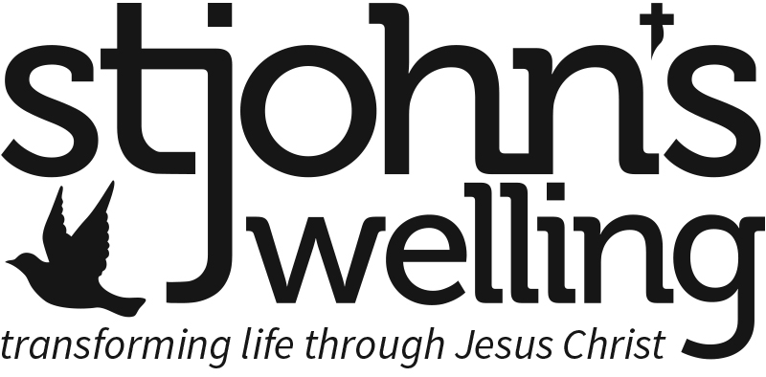

Charity Gift Aid Declaration
Boost your donation by 25p of Gift Aid for every £1 you donate
Gift Aid is reclaimed by the charity from the tax you pay for the current tax year. Your address is needed to identify you as a current UK taxpayer.

In order to Gift Aid your donation you must tick the box below:

• I want to Gift Aid my donation of £______________ and any donations I make in the future or have made in the past 4 years to St John’s Church Welling:

I am a UK taxpayer and understand that if I pay less Income Tax and/or Capital Gains Tax than the amount of Gift Aid claimed on all my donations in that tax year, it is my responsibility to pay any difference.

My Details

Title ____________________ First name or initial(s) ___________________________

Surname _____________________________________________________________

Full Home address _____________________________________________________

_____________________________________________________________________

Postcode ___________________ Telephone(s) ______________________________

Email ___________________________________

Signature ___________________________________ Date _____________________

Please notify us if you:

• want to cancel this declaration
• change your name or home address
• no longer pay sufficient tax on your income and/or capital gains

If you pay Income Tax at the higher or additional rate and want to receive the additional tax relief due to you, you must include all your Gift Aid donations on your Self-Assessment tax return or ask HM Revenue and Customs to adjust your tax code.
This form can also be completed online at www.stjohnswelling.org.uk/xxxxx
Please return the completed form to the Treasurer or Gift Aid Secretary, St John’s Church, Danson Lane, Welling DA16 2BQ. Thank you.

